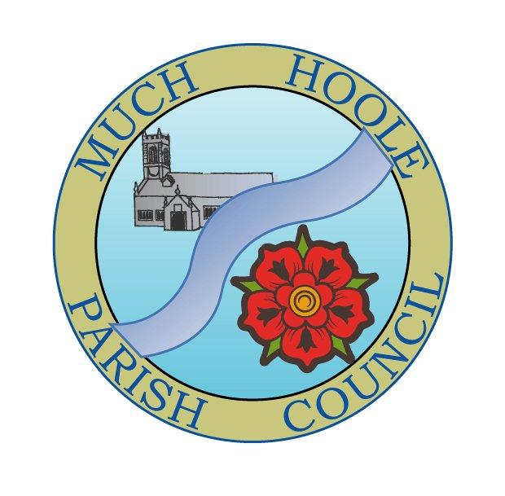 | MUCH HOOLE PARISH COUNCIL  NOTICE OF MEETING
You are hereby summoned to attend the Annual Meeting of Much Hoole Parish Council to be held on Monday 9th May 2022 at 7.30pm. The meeting will be held at the Venue (Hoole Memorial Village Hall), Liverpool Old Road.

Russ Weaver, Clerk to the Parish Council

AGENDA
1. | Election of Chairman of Much Hoole Parish Council for next 12 months
2. | Election of Vice Chairman of Much Hoole Parish Council for next 12 months
3. | Election of representative to attend LALC conference
4. | Apologies for Absence  To receive apologies for absence
5. | Declaration of Interests and Dispensations  - To receive declarations of interest from Councillors on items on the agenda  - To receive written requests for dispensations for disclosable pecuniary interests (if any)  - To grant any requests for dispensation as appropriate
6. | Minutes of the Previous Meetings  To resolve to approve as a correct record the Minutes of the Council Meeting held on the 11th April 2022
7. | Public Time  To invite and listen to issues raised by members of the public.
8. | Planning  A pre planning consultation has been issued in relation to the existing telecoms base station. Views are being sought before an application is submitted  - CS 131603_02 / VF 64466 / SNAYLAMS FARM The works required to the site will include: The replacement of the existing 12m monopole with a new 20m monopole, accommodating 3no. antennas and RRU’s, the replacement of ground-based equipment cabinets, along with ancillary works.  • SNAYLAMS FARM, TURNERS HAULAGES YARD, LIVERPOOL OLD ROAD, MUCH HOOLE, PRESTON, PR4 4GA – NGR: 347666, 423312 This is the preferred option as the site provides adequate coverage, its proposed position is considered suitable in the context for the telecommunications base station. Taking into account the development’s siting and appearance when read in its current environment, it is considered that a scheme in this location will not undermine the visual amenity of the area with minimal impact on the sky-line whilst utilising (upgrading) an existing site.  07/2022/00276/HOH Single Storey side extension following demolition of existing porch, rear conservatory and detached garage. 214 Liverpool Old Road, Much Hoole, PR4 5JU  07/2022/00303/ADV Placing of three free standing information boards at Birchfield, The recreation ground and Moss House Lane/ junction Smithy Lane . Applicant Much Hoole Parish Council
9. | Off Road Cycle Track  To consider any updates on the Cycle track and resolve any actions required.
10. | Finance and audit  To authorise payment of the following:  - To Resolve to pay Clerk salary for April in sum of £240 (net for April)  - To Resolve to re-imburse Clerk in sum of £52.80 for mileage and printer ink  - To resolve to pay HMRC in sum of £60 PAYE for April  - To resolve to pay the invoice for Jubilee event banners and posters in sum of £168 to Poppy Signs ltd  - The Council is asked to NOTE that end of year accounts are now with the internal auditor and should be available for the June meeting. It should also be noted that Mr. Ian Edwards, the internal auditor is retiring shortly and will not be available for audit work next year. The Clerk will find and propose a new internal auditor for future audits.
11. | Lengthsman contract review  The Lengthsman was first engaged three years ago and has not had his contract nor his hourly rate reviewed in that time. The Council is asked to determine what if any increase in his hourly rate should be included in his contract.
12. | Community led projects  To discuss and update progress on the spending of community funding.
13. | Insurance  The current insurance expires on 1st June, 2022. The Council is committed to a three-year deal which set a discounted premium of £479.79 of which the year just gone is year one. The Council is asked to resolve that the Clerk renew the insurance at that premium when the renewal notice is received.
14. | Much Hoole Village Hall  To receive a report on the activities and progress of the Venue.
15. | General Power of competence  The General Power of Competence (GPC) was introduced by the Localism Act 2011 and took effect in February 2012. In simple terms, it gives councils the power to do anything an individual can do provided it is not prohibited by other legislation. An eligible council is one which has resolved to adopt the GPC, with at least two thirds of its members being declared elected and the Clerk must hold an appropriate qualification. Much Hoole Parish Council is therefore eligible to hold the GPC, widening its powers to act on behalf of the local community. The use of the power has to be renewed and agreed at the Annual parish Council meeting  To resolve to adopt the General Power of Competence
16. | Grants  - The Council has a grants application policy which was felt to be too restrictive. A new revised policy has been drafted and it is proposed that this be adopted by the Council.  - The Council has previously set aside a grant of £5,500 to support the building of an annex at the Church for community use, although this money remains in the Council account awaiting the commencement of building work. Work has not started as planned because of escalating material costs and to complete the project will require an additional £24,000 over and above the original figure. A further grant application for the same project has now been received. There is no sum specified but the Council is asked if it would consider a further pledge of funds towards the shortfall.
16. | Local Meetings  - To receive any reports from local meetings.  - To note any forthcoming meetings.
17. | Items for the Next Agenda (for information only)  Internal audit report  Statement of Governance  Statement of accounts  Setting period of public rights to inspect accounts
18. | Date of Next Meeting  The Parish Council to agree the date of the next meeting as 7.30pm Monday 14th June 2021.

